Sweet Little Rosie Rescued by Gretchen Price of Almost Home

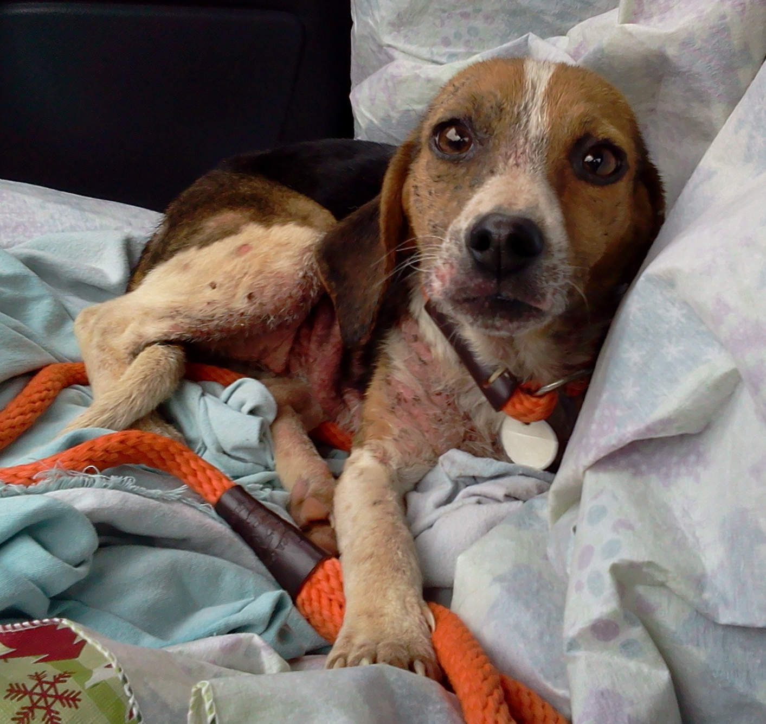

Rosie in Gretchen’s car immediately after Gretchen
rescued her from the middle of the road.

I was going home after my spay/neuter clinic transport one Tuesday morning and had gotten a late start going home. As I headed up Roseland road, I spot this tiny little dog running as fast as she could towards me in the opposite lane. I remember thinking that she was saying, "Oh! Here comes someone. Maybe she'll stop for me." I was told later that others reported seeing her in the vicinity of Tye Brook Highway and Roseland Road. Why did no one pick her up?

I pulled off the road and she came right over to my car. I was able to easily put my slip lead on her and walked her to the passenger side. She sat patiently while I lined the car seat with bedding. When I picked her up she gave me a little kiss on my nose. I placed her on the seat where she curled up and went to sleep right away. She had been out in cold, rainy weather for days most likely, and the heat in the car must have felt so good to her.

It was obvious that Rosie had a really bad case of mange. Just touching her caused her skin to bleed. Later, I noticed that my shirt was covered in blood from where I had held her. She must have been suffering with this painful skin for a very long time. Dr. Ligon said that there were gravels imbedded in places on her body where she probably tried to get relief from the itch by rolling on the ground. Heartbreaking.

When I arrived at Animal Control, I explained where I had found Rosie, to Charlie, the kennel keeper. So, we started brainstorming about names for her; Rosalyn, Rosalee, etc. And then, Charlie said, "How about Rosie?!" Sounded good to me, so it stuck. However, I don't think Rosie will mind a name change if it means a place in a forever home.

Rosie's skin is looking a whole lot better these days, and the hair is beginning to grow back. She clearly feels better and can't get enough attention from our staff and volunteers. It makes me smile every time I think of how she's safe and warm in our care now. Happy endings! That's what we're all about. Gretchen


ROSIE (her new name is GRACIE) in her “FOREVER HOME with the Angells”
on the day they adopted her… 3/2/14

